Infusion bag film
QiluVac is a professional manufacturer of medical infusion bag film, specifically used as secondary packaging for medical infusion bag.
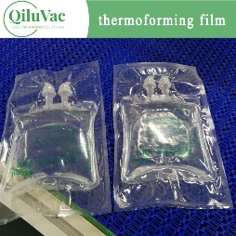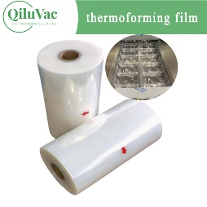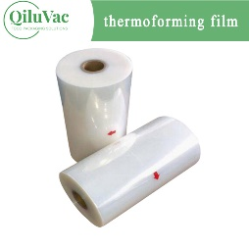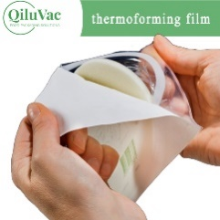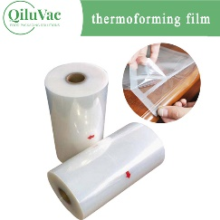
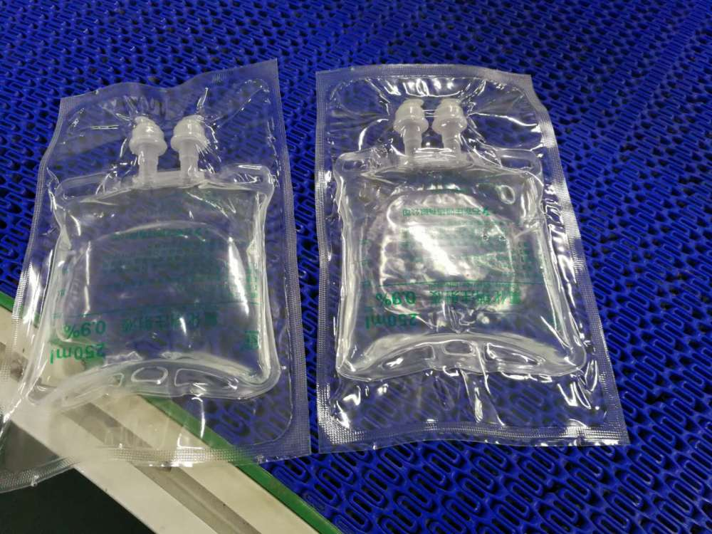
- Product Introduction:

The IV medical infusion bag has an outer packaging to protect it from dust and contamination during transportation, storage, and handling. Such secondary packaging may have high barrier properties to protect fluids from oxygen and other gases. The product’s advanced structural properties can ensure excellent pack sealing after heat treatment.
PA based, Polypropylene (PP) sealant layer
The materials are coextruded film with high barrier property, suitable for thermoforming and able to withstand heat treatment for 121degree high temperature sterilization in autoclaves.
QiluVac is a professional manufacturer of medical infusion bag film, specifically used as secondary packaging for medical infusion bag, and it is automatically formed, sealed, slit, and output by FFS continuous vacuum automatic thermoforming packaging machine, which is hygienic and safe. And the package is easy to open to ensure the efficiency of medical use.
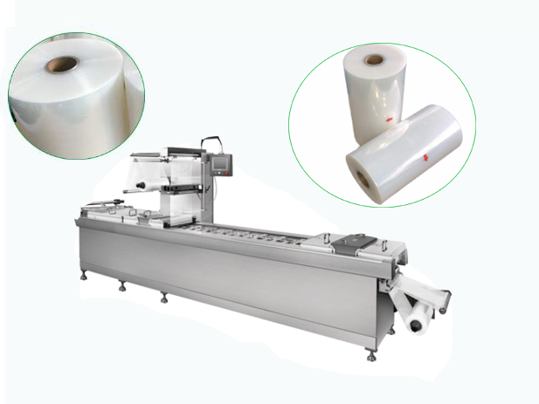
- Product Features:
- Easy open versions can be designed
- Leakage Resistant and high moisture proof.
- High puncture and tear resistance.
- Can be sterilized at the temperature of 121°C
- Quality standard: ISO; SGS; FDA
- Width: 100mm-1200mm; Thickness: 55um-300um

- Our Quality Control:
QiluVac has an advanced quality assurance program compliant of industry requirements and standards achieved by use of our detection flow system. The detection flow system adheres to the following quality control checks:
① Raw material testing
② Process control
③ Product testing
④ Quality checking
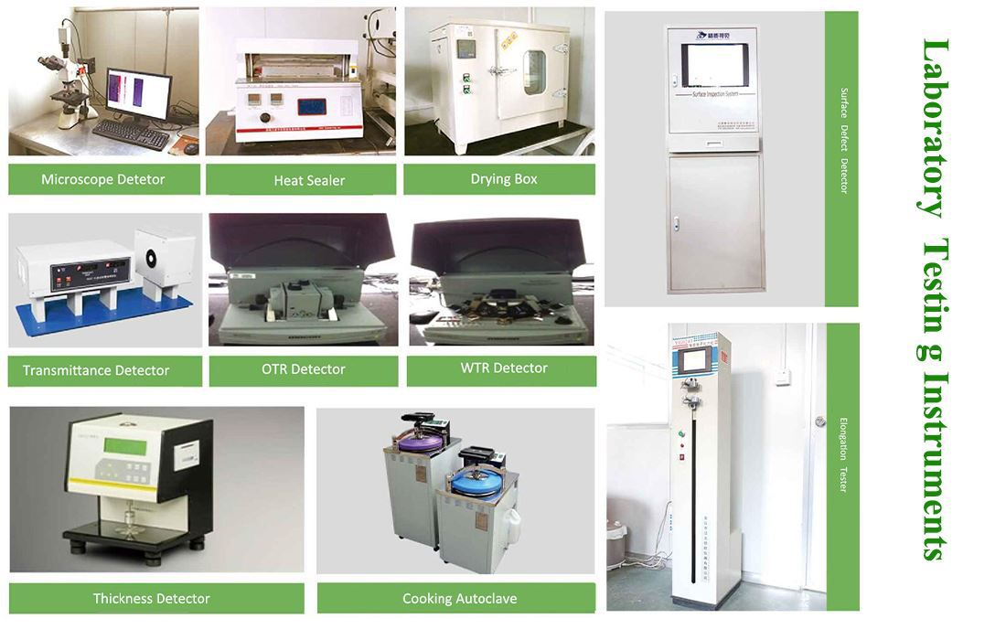
4. Our advantage:
1)Good Reputation. Founded in 1988, with more than 30 years’ experience, good reputation;
2)Professional technical support. Professional technical team and customize packaging solutions;
3)Fast delivery time. Four production lines with an annual output of 8000ton with fast delivery time;
4)Quality Guarantee. ISO, FDA and SGS, all materials are in compliance with FDA Contact Legislation.
5. Our order from customer, for medical infusion bag packaging.
